**37252 Regression and Linear Models**

**Lab 6: Non-linear Regression**

This lab is marked out of 26.

Please save your file in PDF format with name

**37252_Lab6_Surname_FirstName**

**Due: 12 noon Wednesday 24 April 2024**

In this week’s lab model octopus beak weight. The data are a sample from 30 octopi and available in **37252_Lab6_data.csv** which can be downloaded from Canvas.

The variables we now consider are summarised in the table below.

|  |  |  |
| --- | --- | --- |
| **Name** | **Role** | **Description** |
| $$weight$$ | response | weight of octopus beak |
| $$wall$$ | predictor | length of lateral wall of octopus beak |

Below is a scatter plot of the data (see previous labs for graphing instructions).

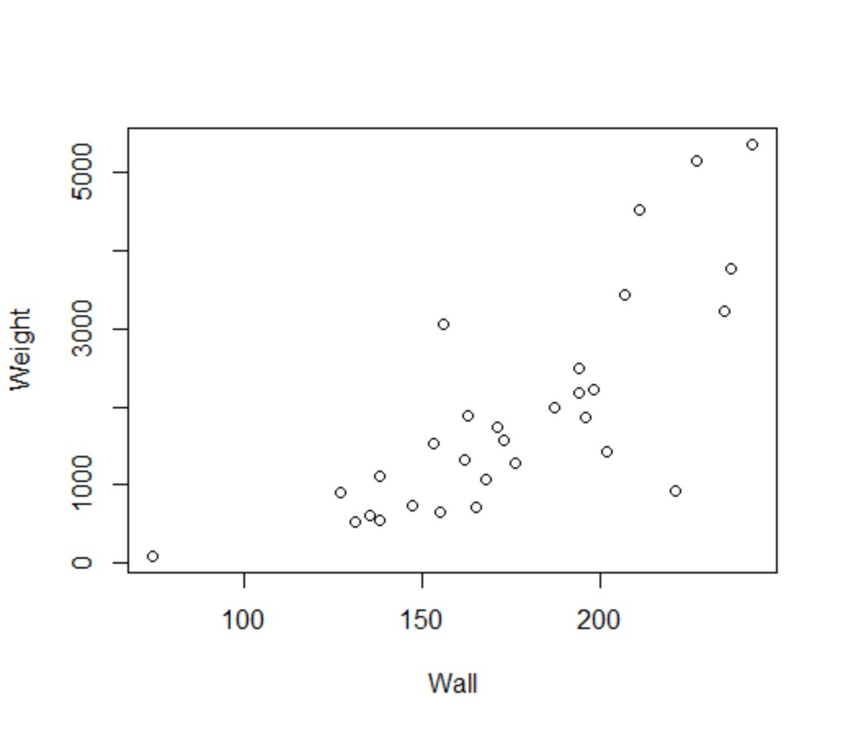

1. Describe the direction, type and strength of the relationship between $wall$ and $weight$**[3 marks]**.
2. If a straight-line model was fitted to the data, what two problems would we see with the residuals **[2 marks]**?

Let’s ignore the curvature in the data (hint!) and build a straight-line regression model of $weight$ against $wall$, making sure to request a histogram and PP plot and to save the standardised residuals.

1. Write down the estimated regression model **[1 mark]** and provide interpretations of the estimated beta coefficients **[2 marks]**.
2. Perform a visual analysis of the residuals for compliance with the normality, independence and constant variance assumptions **[3 marks]**.

Let’s now try to deal with the curvature with a polynomial regression by replacing $wall$ with $wallSqrd={wall}^{2}$ as the predictor (you will need to create the variable $wallSqrd$– see previous labs for instructions). Again, request a histogram and PP plot and save the standardised residuals.

1. Write down estimated the regression model **[1 mark]** and provide interpretations of the estimated beta coefficients **[2 marks]**.
2. Perform a visual analysis of the residuals in this polynomial model for compliance with the normality, independence and constant variance assumptions **[3 marks]**.

The polynomial model has removed the curvature in the residuals but the increasing variance remains (hint!). There are a couple of ways we can approach this; next week we will look at weighted least squares (WLS) regression but here we will make a log transform of weight.

Construct a model with $weightLn=ln⁡(weight)$ as response and ${wall}^{2}$ as predictor, again requesting residuals plots and saving the standardised residuals and Cook’s distances.

1. Write down the estimated regression model in log-units **[1 mark]** and provide interpretations of the estimated beta coefficients **[2 marks]**. Re-write the regression equation in original units of $weight$**[1 mark]** and re-interpret the estimated exponential of the beta coefficients **[2 marks]**.
2. Perform a visual analysis of the residuals in this log-units model for compliance with the normality, independence and constant variance assumptions **[3 marks]**.

**Extra work [0 marks].** Identify and filter out any influential points, run the model again and see if this improves the residuals with respect to the assumption of normality.