**37252 Regression and Linear Models**

**Lab 9: Simple Logistic Regression**

This lab is marked out of 26.

Please save your file in PDF format with name

**37252_Lab9_Surname_FirstName**

**Due: 12 noon Wednesday 15 May 2024**

In this week’s lab we continue our example from last week. The data are available in **37252_Lab9_data.csv** which can be downloaded from Canvas.

The variables we consider are summarised in the table below.

|  |  |  |
| --- | --- | --- |
| **Name** | **Role** | **Description** |
| $$good$$ | response | successful field goal attempt: 1 (yes), 0 (no) |
| $$qtr$$ | predictor | game time quarter (1, 2, 3, 4) |
| $$distance$$ | predictor | kicking distance |

**Simple logistic regression with categorical variable**

Recall from Lab 8 that we found there was no statistically-significant relationship between $good$ and $qtr$. Let’s ignore this for the moment and fit a logistic regression model anyway.

As $qtr$ is a four-state categorical variable, we require three binary dummy variables. We will code them as

$$\left({qtr}_{1},{qtr}_{2},{qtr}_{3}\right)=\left\{\begin{aligned}\left(1,0,0\right), qtr=1 \\ \left(0,1,0\right), qtr=2 \\ \begin{matrix}\left(0,0,1\right), qtr=3 \\ \left(0,0,0\right), qtr=4\end{matrix}\end{aligned}.\right.$$

We need to specify this variable as a “factor” before fitting the model.

> read.csv("~/2024_37252/Labs/Lab9/37252_Lab9_data.csv")

> NFLdat$qtr <- as.factor(NFLdat$qtr)

> NFLdat$qtr <- relevel(NFLdat$qtr, ref = "4")

> mod1 <- glm(good ~ qtr, family = "binomial", data = NFLdat)

> summary(mod1)

R output is displayed below.

Call:

glm(formula = good ~ qtr, family = "binomial", data = NFLdat)

Deviance Residuals:

Min 1Q Median 3Q Max

-2.1330 0.4658 0.4914 0.5851 0.5851

Coefficients:

Estimate Std. Error z value Pr(>|z|)

(Intercept) 2.0532 0.1972 10.410 <2e-16 ***

qtr1 0.1132 0.2993 0.378 0.705

qtr2 -0.3750 0.2429 -1.544 0.123

qtr3 -0.3485 0.2848 -1.224 0.221

---

Signif. codes: 0 ‘***’ 0.001 ‘**’ 0.01 ‘*’ 0.05 ‘.’ 0.1 ‘ ’ 1

(Dispersion parameter for binomial family taken to be 1)

Null deviance: 810.25 on 1025 degrees of freedom

Residual deviance: 805.10 on 1022 degrees of freedom

AIC: 813.1

Number of Fisher Scoring iterations: 4

1. Write down the fitted logistic regression model in log-odds scale, odds scale and probability scale **[3 marks]**.

Let

$$\hat{p}\left(qtr\right)=\hat{Prob}\left(good=1 | qtr\right).$$

**Log-odds scale**

$$\log{\frac{\hat{p}\left(qtr\right)}{1-\hat{p}\left(qtr\right)}}=2.053+0.113×{qtr}_{1}-0.375×{qtr}_{2}-0.348×{qtr}_{3}$$

**[1 mark]**

**Odds scale**

$$\frac{\hat{p}(qtr)}{1-\hat{p}(qtr)}=e^{2.053+0.113×{qtr}_{1}-0.375×{qtr}_{2}-0.348×{qtr}_{3}}$$

**[1 mark]**

**Probability scale**

$$\hat{p}(qtr)=\frac{1}{1+e^{-2.053-0.113×{qtr}_{1}+0.375×{qtr}_{2}+0.348×{qtr}_{3}}}$$

**[1 mark]**

Recall in Lab 8 we used two-way table analysis to calculate

$$odds\left(qtr=1\right)=8.727$$

$$odds\left(qtr=4\right)=7.793$$

$$oddsRatio\left(qtr=1 v. qtr=4\right)=1.120$$

1. Using the regression model, carry-out the calculations to show that the odds of successful field goal in quarter 1 and in quarter 4 almost match those calculated in Lab 8 **[2 marks]**. Using the regression model (or R output) show that the odds ratio almost matches that from Lab 8 **[1 mark]**.

$$\hat{odds}\left(qtr=1\right)=\frac{\hat{p}\left(qtr=1\right)}{1-\hat{p}\left(qtr=1\right)}=e^{2.053+0.113×1-0.375×0-0.348×0}$$

$$=8.72$$

$$\hat{odds}\left(qtr=4\right)=\frac{\hat{p}\left(qtr=4\right)}{1-\hat{p}\left(qtr=4\right)}=e^{2.053+0.113×0-0.375×0-0.348×0}$$

$$=7.79$$

**[2 marks]**

$$\hat{oddsRatio}\left(qtr=1 v. qtr=4\right)=\frac{\hat{odds}\left(qtr=1\right)}{\hat{odds}\left(qtr=4\right)}$$

$=1.120$

The last can be obtained directly from the Variables in the Equation table output by R, i.e. $e^{β_{{qtr}_{1}}}=1.120$.

**[1 mark]**

1. Determined if the model predicts a successful field goal for kicks taken in quarter1 and in quarter 4, i.e. determine if

$$\hat{good}\left(qtr=1\right)=1$$

and

$$\hat{good}\left(qtr=4\right)=1.$$

**[3 marks]**

We need to check if $\hat{p}\left(qtr=1\right)>0.5$ and if $\hat{p}\left(qtr=4\right)>0.5$**[1 mark]**.

The model does predict successful field goal kicks in quarter 1 because

$$\hat{p}\left(qtr=1\right)=\frac{1}{1+e^{-2.053-0.113×1+0.375×0+0.348×0}}=0.897>0.5$$

which implies

$$\hat{good}\left(qtr=1\right)=1.$$

**[1 mark]**

The model does predict successful field goal kicks in quarter 4 because

$$\hat{p}\left(qtr=4\right)=\frac{1}{1+e^{-2.053-0.113×0+0.375×0+0.348×0}}=0.886>0.5$$

which implies

$$\hat{good}\left(qtr=4\right)=1.$$

**[1 mark]**

1. Provide interpretations of ${\hat{β}}_{{qtr}_{1}}=0.113$ on the log-odds scale and of $e^{{\hat{β}}_{{qtr}_{1}}}=1.120$ on the odds scale **[2 marks]**.

The coefficient ${\hat{β}}_{{qtr}_{1}}=0.113$ is the predicted difference in the log-odds of successful field goal in quarter 1 compared to quarter 4 **[1 mark]**.

The odds ratio $e^{{\hat{β}}_{{qtr}_{1}}}=1.120$ is the predicted multiple of the odds of successful field goal in quarter 1 compared to quarter 4 **[1 mark]**.

**Simple logistic regression with continuous predictor**

Recall from Lab 8 that we found there was a statistically-significant relationship between $good$ and $distanceBin$, where $distanceBin$ represented kick distance quartile. Let’s infer from this the existence of a statistically-significant relationship between $good$ and $distance$ and build a logistic regression model.

> mod2 <- glm(good ~ distance, family = "binomial", data = NFLdat)

> summary(mod2)

R output is displayed below.

Call:

glm(formula = good ~ distance, family = "binomial", data = NFLdat)

Deviance Residuals:

Min 1Q Median 3Q Max

-2.9500 0.2047 0.3491 0.5846 1.2341

Coefficients:

Estimate Std. Error z value Pr(>|z|)

(Intercept) 6.75473 0.54691 12.351 <2e-16 ***

distance -0.12083 0.01234 -9.788 <2e-16 ***

---

Signif. codes: 0 ‘***’ 0.001 ‘**’ 0.01 ‘*’ 0.05 ‘.’ 0.1 ‘ ’ 1

(Dispersion parameter for binomial family taken to be 1)

Null deviance: 810.25 on 1025 degrees of freedom

Residual deviance: 680.53 on 1024 degrees of freedom

AIC: 684.53

Number of Fisher Scoring iterations: 6

1. Write down the fitted logistic regression model in log-odds scale, odds scale and probability scale **[3 marks]**.

Let

$$\hat{p}\left(distance\right)=\hat{Prob}\left(good=1 | distance\right).$$

**Log-odds scale**

$$\log{\frac{\hat{p}\left(distance\right)}{1-\hat{p}\left(distance\right)}}=6.755-0.121×distance$$

**[1 mark]**

**Odds scale**

$$\frac{\hat{p}\left(distance\right)}{1-\hat{p}\left(distance\right)}=e^{6.755-0.121×distance}$$

**[1 mark]**

**Probability scale**

$$\hat{p}(distance)=\frac{1}{1+e^{-6.755+0.121×distance}}$$

**[1 mark]**

1. Interpret the impact of $distance$ on the log-odds scale and the odds scale **[2 marks]**.

**Log-odds scale**

For a unit increase in $distance$, the log-odds of successful field goal are predicted to fall by 0.121 **[1 mark]**.

**Odds scale**

For a unit increase in $distance$, the odds of successful field goal are predicted to multiply by $e^{-0.121}=0.866$**[1 mark]**.

1. Perform a hypothesis test to determine if the regression is significant at the 0.05 level. Write down the hypotheses **[1 mark]**, the test statistic and p-value **[1 mark]**, the result of the test **[1 mark]** and a conclusion in non-mathematical language **[1 mark]**.

**Hypotheses**

$$H_{0}: β_{distance}=0$$

$$H_{A}: β_{distance}≠0$$

**[1 mark]**

**Test statistic and p-value**

Test statistic $Z^{*}=-9.788$ with p-value $p=0.000$**[1 mark]**.

**Test result**

Reject $H_{0}$ as $p<0.05$**[1 mark]**.

**Conclusion**

The regression is significant **[1 mark]**.

1. Use a scatterplot to plot $\hat{p}$ against $distance$ and describe the relationship **[2 marks]**.

> plot(NFLdat$distance , mod2$fitted.values, xlab = "Distance", ylab = "Predicted probability")

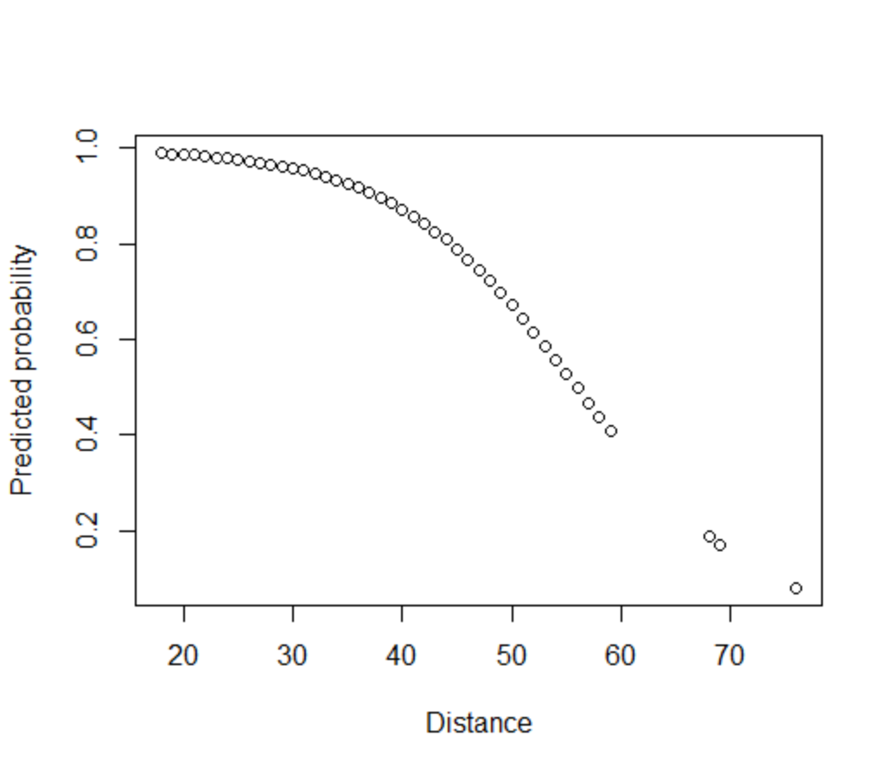

$$\lim_{distance→0}{\hat{p}}\left(distance\right)=1$$

and

$$\lim_{distance→∞}{\hat{p}}\left(distance\right)=0.$$

**[2 marks]**

1. Calculate the “median effective level” ${distance}_{mel}$ by solving

$$\hat{p}\left(distance\right)=1/2$$

for $distance$**[2 marks]**. Describe the relationship between ${distance}_{mel}$ and $\hat{good}$**[2 marks]**.

From the equation for the log-odds we have

$$distance=\frac{\log{\frac{\hat{p}\left(distance\right)}{1-\hat{p}\left(distance\right)}-6.755}}{-0.121}.$$

**[1 mark]**

Making the substitution gives

$${distance}_{mel}=\frac{\log{\frac{\hat{p}\left(1/2\right)}{1-\hat{p}\left(1/2\right)}-6.755}}{-0.121}=\frac{6.755}{0.121}$$

$$=55.826.$$

**[1 mark]**

For $distance>{distance}_{mel}$ we have $\hat{p}<1/2$ implying $\hat{good}=0$**[1 mark]**.

For $distance<{distance}_{mel}$ we have $\hat{p}>1/2$ implying $\hat{good}=1$**[1 mark]**.