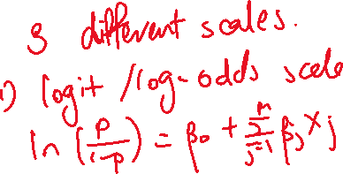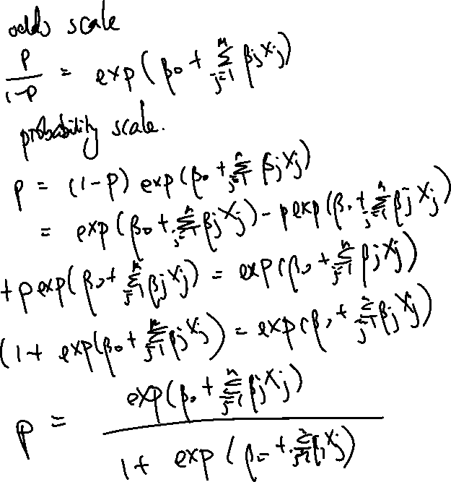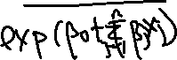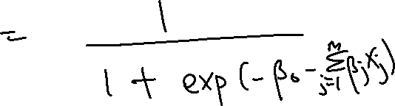

\

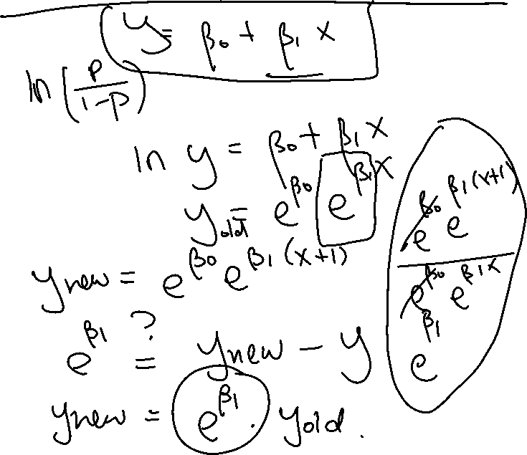

1. Interpretation of beta coefficients on the log odds scale when x is continuous
2. Interpretation of beta coefficients on the odds scale when x is continuous
3. Interpretation of beta coefficients on the log odds scale when x is categorical
4. Interpretation of beta coefficients on the odds scale when x is categorical