|  |  |  |
| --- | --- | --- |
| 32144  Technology Research Preparation | **Week 5 Tutorial 4 Overview** | |
| **Topics**  **Covered:** | Synthesizing the Literature |
| Themes & Synthesis Framework |
| Synthesis Matrix |
| **Points:** | 6 |
| **Date Due:** | Week 5 – In Class |
| **Submission** | In-class contribution to discussions during Week 5 tutorial session |
|  |  |

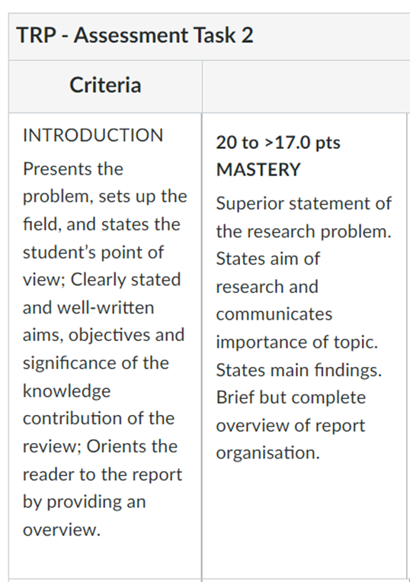**Week 5 Tutorial Preparation – Preparation of Assignment 2 Introduction.**

On the following page, write a draft Introduction for your literature review assignment based on your analysis of the rubric. We covered this in Week 4 lecture.

Your tutor will arrange either a presentation and discussion tor your group or to the tutorial class.

These bullet points were derived from the Rubric of Assignment 2 (opposite).

Your single page draft should include the following information:

* State the Research Problem
* State aim of research
* Importance of the research
* State Main Findings – what is the knowledge gap that you have discovered?
* Brief but complete overview of report organization.

These bullet points ensure that you meet the requirements of the rubric.

**Write Your Draft Introduction to Assignment 2 Literature Review.**

**Week 5 Tutorial Preparation – Reading and Analyzing Papers**

1. **CONTINUE IDENTIFYING AND READING PAPERS** – You should have identified at least seven relevant research articles from the academic and/or industry databases by the end of this week and be finalising the main sources you will use in your literature review. You should use academic or industry databases (such as ProQuest Central, Google Scholar, *Scopus* (Elsevier) *Web* of Science, and Discovery (EBSCO)) or industry report databases (Gartner.com, IBIS Industry World Reports), which are available via the UTS Library website (Refer to Week 3 Lecture).
2. **FINALISE YOUR MOST RELEVANT PAPERS FOR YOUR REVIEW** – This week you should be identifying the **most relevant papers you have sourced to date**. From the sources you have collected, begin to shortlist conference papers, journal articles and industry reports. You do not need to have this task completed before your tutorial in Week 5, however you should **have identified 4-5 papers** that you can use to develop ideas for your synthesis framework (see below).

**THINK ABOUT AND REFLECT ON MAIN THEMES** – Using your research question and your most relevant papers, identify a few of the **major themes** that you can use to critical evaluate and analyse your sources. You have already created search criteria for selecting the papers, which is a starting point for your major themes. Now you need to go deeper into those sources to identify your major themes, which should be identified relative to the concepts that define your topic, and can be based on e.g., Linkages and connections, Trends and similarities, Contradictions and contrasts, and Causes, factors, variables, etc.

1. **Read the paper by Denney and Tewksbury (2013)**: You will recall from Week 5 that there are different purposes and approaches to writing a literature review. Denney & Tewksbury (2013) highlight the three primary functions of a literature review: **integrative**, **theoretical**, or **methodological**.

“Reviews may be **integrative** (summarizing past research based on overall conclusions of the past research), **theoretical** (identifying and critiquing the ability of different theories to explain a phenomenon), or **methodological** (highlighting different methodological approaches used in past research and the contributions of each type of research) in focus."[1]

**In-Class Tutorial Activities**

1. **EXPLORING YOUR MAJOR THEMES**

**ACTIVITY 1: Identify and Discuss Your Major Themes** – In breakout groups, identify themes that you can use to critically evaluate and analyse your sources. As stated above, you should identify themes relative to the concepts that define your topic, and can be based on e.g.,

* Linkages and connections,
* Trends and similarities,
* Contradictions and contrasts,
* Causes, factors, variables, etc.

**Topic:**

Major Theme 1:

Major Theme 2:

Major Theme 3:

NB: Your major themes should frame your research problem and provide supporting arguments for your research question, statement and purpose, and ultimately define the objectives of your research proposal (Task 3). Figure 1, shows this funnelling effect that your major themes should support.

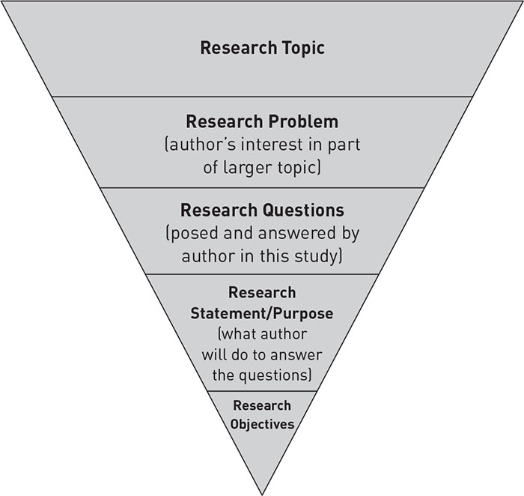

From General

to

Very Specific

What will be address in a particular study

Author’s topic of interest

Figure 1. Research Topic, Research Problem, Research Question, Research Statement/ Purpose, Research Objectives. The research problem is the author’s topic of interest within a larger area of interest (research topic), and the research question and the research statement reflect what will be addressed in a particular study. In other words, authors move from the general to very specific as they set up their paper. The Introduction section of the papers you are reviewing will contain all of these, and the good ones should achieve this as an inverted triangle or cone.

1. **DEVELOPING YOUR THEME & SYNTHESIS FRAMEWORK**

**ACTIVITY 2: Identify and Discuss the Relationships between Your Major Themes** – Using the major themes that you have identified from the literature identify any relationships between them and create a relationship diagram to map any associations between them.

**You MIGHT USE RELATIONSHIP DIAGRAMS SUCH AS:**

1. Cause and effect diagram
2. Venn diagram (see example in figure 3 below)
3. Hierarchical diagram
4. Process / cycle diagram … etc

Figure 3. Venn Diagram

1. **COMPLETING THE SYNTHESIS MATRIX** –

**ACTIVITY 3: Register and then Discuss a Source Article** – Complete the synthesis matrix for one or even two articles during the tutorial (depending on time). Before then sharing the results in a feedback discussion.

NB: Please use APA Referencing (Authors, Date, Title, etc.) for your selected conference paper, journal article or industry report.

**NB:** You can use the matrix below or use the excel spreadsheet that is available on Canvas.

**In-Class Tutorial Activities – use this sYNTHESIS MATRIX to synthesise the articles**

|  |  |  |  |  |  |
| --- | --- | --- | --- | --- | --- |
| **SOURCE (Author/s)** | **SOURCE A  (E.G., DENNEY & TEWKSBURY)** | **SOURCE B** | **SOURCE C** | **SOURCE D** | **SOURCE …** |
| **YEAR** | **2013** |  |  |  |  |
| **MAIN CONCEPT/ THEME** | Here I list the **main concept or the major theme of the paper** that is specifically related to my topic and my literature review |  |  |  |  |
| **OVERVIEW** | Here I **summarise the article in a sentence or two**. It can be based on the abstract but should be more specifically related to the article’s relevance to your research topic. |  |  |  |  |
| **METHODS** | Here I summarise the **research methods used** (e.g., interviews, surveys, experiments, literature review). |  |  |  |  |
| **RESEARCH DESIGN** | Here I describe the **approach to the research** (qualitative or quantitative) |  |  |  |  |
| **MAJOR THEME 1** Based on Major Themes, Connections, Causes, Factors, etc. to your Research Topic/ Question | Here I make notes about **a specific theme in the article that is relevant to my research topic**/ question. I usually try to insert a quote or an image that relates to this theme. + Pg. No. I may also note the extent that I agree or disagree. |  |  |  |  |
| **MAJOR THEME 2** Based on Major Themes, Connections, Causes, Factors, etc. to your Research Topic/ Question | Here I make notes about a **second theme in the article that is relevant to my research topic/ question**. I usually try to insert a quote or an image that relates to this theme. + Pg. No. I may also note the extent that I agree or disagree. |  |  |  |  |
| **MAJOR THEME 2** Based on Major Themes, Connections, Causes, Factors, etc. to your Research Topic/ Question | Here I make notes about **a third theme in the article that is relevant to my research topic/ question**. I usually try to insert a quote or an image that relates to this theme. + Pg. No. I may also note the extent that I agree or disagree. |  |  |  |  |
| **KEY REFERENCES** | Here I list the references or citations that link the article to other research articles that I have identified as being important to my research topic. |  |  |  |  |
| **CONCLUSIONS OR MAIN “TAKE-AWAYS”** | Based on the paper’s conclusions, what are **the main take-aways** that are pertinent to my own Research Topic/ Question. I note the extent that I agree or disagree with the paper’s conclusions. I briefly comment why I agree/ disagree. |  |  |  |  |
| **RESEARCH GAPS** | Here I **identify the gaps** in the article. With regard to your research problem, what key issues has the article not addressed. You can identify them or find them in the section on limitations and areas for future research. |  |  |  |  |
| **KIND OF LITERATURE REVIEW** | Classify the **article’s literature review**. Here I note the kind of literature review the authors presented. It is either integrative, theoretical, or methodological |  |  |  |  |
| **PUBLICATION TYPE** | Book/ Book Chapter/ Journal Article/ Conference Paper/ Government or Commercial Consultant Report/ Industry Journal/ Website Article |  |  |  |  |

**References**

Here I list the full **APA citation** (of the article, book, book chapter, etc. provided in the table above)

**For example:**

Denney, A. S., & Tewksbury, R. (2013). How to write a literature review. *Journal of criminal justice education, 24*(2), 218-234.

1. Denney, A. S., & Tewksbury, R. (2013). How to write a literature review. Journal of criminal justice education, 24(2), 218-234.